Experiment No: 9 Date:

**Implementation of Non-Inverting Amplifier using Op-amp**

**Aim:**

Design a non-inverting amplifier for gain 11.

**Components and Equipments required:**

Oscilloscope, Function generator, Multimeter, Bread board, resistors, Op-amp, connecting wires, tweezer, wire stripper.

**Theory:**

The word ‘operational’ in operational amplifier originally stands for mathematical operations. Early op-amps were used in circuits that could add, subtract, multiply and even solve differential equations. These operations have given way to digital computers because of their speed and accuracy.

**Non Inverting Amplifier**

In a non-inverting amplifier, the input signal Vi is applied to the op-amps (+) input. The input resistance of the inverting amplifier is Ri, but the input resistance of the non-inverting amplifier is extremely large, typically exceeding 100MΩ. The output voltage Vo is given by

Vo= [1+Rf/Ri]Vi.

The closed loop gain of the amplifier Acl = Vo/Vi = 1+ [ Rf/Ri ]. The output voltage has the same polarity as the input voltage. The gain of a non-inverting amplifier is always greater than 1.

**Circuit Diagram:**

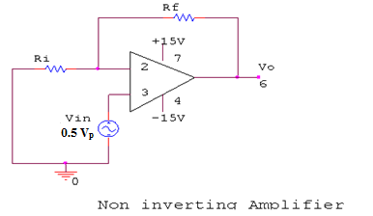

. **Procedure:**

a. An ac input of 0.5Vp is generated using a signal generator and given to pin 3.

b. Pin 2 is grounded through a Ri resistor.

c. A resistor of Rf is connected between pin 2 and pin 6.

d. V+ (7th pin) and V- (4th pin) of op-amp are connected to +15V and -15V.

e. The output signal is taken from pin 6 and viewed through the CRO.

**Result:**

Experiment No: 10 Date:

**Implementation of Inverting Amplifier using Op-amp**

**Aim:**

Design an inverting amplifier for gain 10.

**Components and Equipments required:**

Oscilloscope, Function generator, Multimeter, Bread board, resistors, Op-amp, connecting wires, tweezer, wire stripper.

**Theory:**

The word ‘operational’ in operational amplifier originally stands for mathematical operations. Early op-amps were used in circuits that could add, subtract, multiply and even solve differential equations. These operations have given way to digital computers because of their speed and accuracy.

**Inverting Amplifier**

An amplifier is a circuit that receives a signal at its input and delivers an undistorted layer version of the signal at its output. The inverting amplifier can amplify ac or dc signals. The input signal Vi is applied through the input resistor Ri to the op-amps (-) input. Negative feedback is provided by feedback resistor Rf. The voltage between the (+) and (-) inputs is essentially equal to 0V. The output voltage Vo is given by

Vo= -Vi [ Rf / Ri]

The closed loop gain of the amplifier Acl = Vo/Vi = - [ Rf /Ri] The minus sign shows that the polarity of all output Vo is inverted with respect to Vi. For this reason this circuit is called an inverting amplifier.

**Circuit Diagram:**

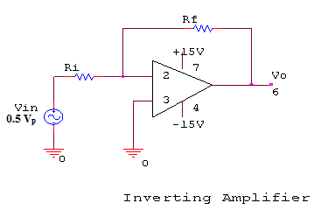

**Procedure:**

a. An ac signal of 0.5Vp is connected to a Ri resistor and is connected to pin 2.

b. Pin 3 is grounded.

1. A resistor of Rf is connected between pin 2 and pin 6.
2. V+ (7th pin) and V- (4th pin) of op-amp are connected to +15V and -15V.
3. The output signal is taken from pin 6 and viewed through the CRO.

**Result:**